Automating Appointment Scheduling for Clinic

**Minor Project-II**

**(ENSI252)**

*Submitted in partial fulfilment of the requirement of the degree of*

**BACHELOR OF TECHNOLOGY**

*to*

**K.R Mangalam University**

*by*

## **Payal (2301360028)**

## **Nandini (2301360031)**

Under the supervision of

**Dr. Ravinder Beniwal Dr. Sandeep Goyal**

**Faclty Mentor Industry Mentor**

**Goyal Diagonstic Clinic**



Department of Computer Science and Engineering

School of Engineering and Technology

K.R Mangalam University, Gurugram- 122001, India

April 2025

**CERTIFICATE**

This is to certify that the Project Synopsis entitled, **“Automating Appointment scheduling for clinic”** submitted by “**Payal(2301360028), Nandini(2301360031)”** to **K.R Mangalam University, Gurugram, India,** is a record of bonafide project work carried out by them under my supervision and guidance and is worthy of consideration for the partial fulfilment of the degree of **Bachelor of Technology** in **Computer Science and Engineeringwith specialization in (UX&UI)** of the University.

**Type of Project :- IndustryDriven**

Dr. Ravinder Beniwal

Faculty Mentor

Signature of Project Coordinator

Date:

**INDEX**

|  |  |  |
| --- | --- | --- |
| Sr. No. | Titles | P No. |
|  | Abstract | 1 |
|  | Introduction | 2 |
|  | Motivation | 4 |
|  | Literature Review/Comparative work evaluation | 5 |
|  | Gap Analysis | 8 |
|  | Problem Statement | 11 |
|  | Objectives | 12 |
|  | Methodology & Tools/platform Used | 13 |
|  | Wireframes | 19 |
|  | Expected Results And Impact | 23 |
|  | Future Work | 25 |
|  | Conclusion | 26 |
|  | References | 27 |

**ABSTRACT**

Automating appointment scheduling in clinics enhances efficiency, reduces administrative workload, and improves patient experience by eliminating manual booking processes. A digital system integrated with AI and cloud computing allows real-time scheduling, automated reminders, and seamless coordination with electronic health records (EHR). This reduces scheduling conflicts, minimizes no-shows, and optimizes resource utilization. Key benefits include increased accessibility, streamlined operations, and improved patient satisfaction. However, challenges such as data security, system interoperability, and user adoption must be addressed. Overall, automation in appointment scheduling transforms clinic management, making healthcare services more efficient and patient-centric.

***KEYWORDS: Appointment Scheduling, Automation, Clinics, Healthcare Management, Artificial Intelligence, Electronic Health Records (EHR), Patient Experience, Digital Health, Resource Optimization, Scheduling Efficiency.***

**Chapter 1**

**Introduction**

1. **Background of the project**

Effective appointment scheduling is a backbone for smooth clinic operations and positive patient experiences. Traditionally, clinics have relied on manual methods like walk-ins, phone-based bookings, and basic digital calendars, which often lead to issues such as long waiting times, scheduling errors, double bookings, and patient dissatisfaction. These methods also place a heavy administrative burden on clinic staff and limit a clinic’s ability to manage appointments dynamically.

With the growing demand for faster healthcare services and the widespread adoption of technology, clinics are shifting toward **automated appointment scheduling systems**. These systems leverage AI, machine learning, and cloud technology to automate the booking process, predict patient no-shows, optimize scheduling slots, send reminders, and integrate patient data securely with Electronic Health Records (EHR).

Automated systems not only help clinics in managing appointments more efficiently but also empower patients by offering easy access to self-service portals for booking, rescheduling, or canceling appointments. This increases patient satisfaction, improves healthcare accessibility, and reduces operational costs for healthcare providers.

Several automated appointment scheduling applications are already in the market, each offering a set of features aimed at improving clinic management. However, many existing solutions either focus only on certain specialties, are costly for small clinics, or lack full integration with local healthcare workflows. Recognizing these gaps, this project aims to design an AI-driven, user-friendly, and affordable appointment scheduling system tailored to the needs of clinics, ensuring efficiency, scalability, and data security.

Table 1. Existing systems

|  |  |  |
| --- | --- | --- |
| **`App Name** | **Key Features** | **Limitations** |
| **AxonWeb** | Practice management, appointment scheduling, EHR integration | Complex setup process, high learning curve |
| **Ada** | AI-based symptom assessment, appointment referrals | Focused more on diagnosis than pure scheduling |
| **Medanta eClinic** | Patient appointments, remote consultations, medical record management | Limited availability to Medanta network clinics |
| **HealthTap** | Online doctor consultations, AI triage, appointment scheduling | Primarily for virtual consultations, less focus on physical clinic bookings |
| **Practo** | Patient appointment booking, reminders, telemedicine services | Expensive for small clinics, limited customization |

1. **MOTIVATION**

# In today’s fast-paced healthcare environment, efficient patient management is crucial for delivering high-quality medical services. One of the primary challenges faced by clinics is handling appointment scheduling effectively. Traditional scheduling methods, such as phone calls, manual registers, and in-person bookings, are time-consuming and prone to errors. Patients often face difficulties securing appointments due to long wait times, scheduling conflicts, or a lack of real-time availability updates. At the same time, clinics struggle with inefficient resource allocation, missed appointments, and increased administrative workload. These inefficiencies not only affect the overall patient experience but also contribute to financial losses for healthcare providers.

Another major concern is the high no-show rate, which disrupts clinic operations and leads to underutilization of medical staff and equipment. Studies show that missed appointments result in lost revenue and delay access to care for other patients who need timely medical attention. Furthermore, manual scheduling requires significant human intervention, leading to increased administrative costs and potential errors in maintaining records and follow-ups.

With the advancement of digital technologies such as artificial intelligence (AI), cloud computing, and electronic health records (EHR), there is an opportunity to revolutionize clinic appointment scheduling through automation. An AI-powered scheduling system can intelligently manage time slots, send automated reminders via SMS or email, and integrate seamlessly with patient records to ensure optimal scheduling efficiency. By leveraging such a system, clinics can reduce patient wait times, minimize scheduling conflicts, and optimize resource allocation while improving overall patient satisfaction.

The motivation behind this project is to develop a robust, intelligent, and user-friendly appointment scheduling system that enhances operational efficiency, reduces administrative burdens, and improves accessibility to healthcare services. By automating the process, clinics can focus more on patient care rather than administrative tasks, ultimately leading to a more effective and patient-centric healthcare system.

**Chapter 2**

**LITERATURE REVIEW**

1. **Review of existing literature**

The automation of appointment scheduling in healthcare has been extensively studied due to its potential to improve patient experience, optimize resource utilization, and enhance clinic efficiency. Several research studies and technological advancements have explored different approaches to solving scheduling inefficiencies, including artificial intelligence (AI), machine learning, cloud computing, and electronic health records (EHR) integration

**Challenges of Traditional Scheduling**

* Manual and phone-based booking systems lead to inefficiencies, scheduling conflicts, and long wait times (Gupta & Denton, 2008).
* High no-show rates result in resource underutilization and financial losses (Huang & Zuniga, 2014).

**Technological Advancements in Scheduling**

* The systems optimize time slots and predict patient arrival patterns (Topaloglu & Ozkarahan, 2019).
* Cloud-based scheduling integrates with electronic health records (EHR) for real-time updates (Kim et al., 2020).

**AI and Automation Benefits**

* The chatbots enhance patient engagement with self-service booking (Park et al., 2021).
* Automated reminders via SMS and email reduce no-show rates and improve scheduling efficiency (Carrasco et al., 2021).

**Challenges in Implementation**

* Concerns about data security, privacy, and system interoperability (Rojas & Banerjee, 2023).
* Resistance to technology adoption, especially among elderly patients.

**Conclusion**

* Automating appointment scheduling improves efficiency, reduces administrative workload, and enhances patient satisfaction.
* The project aims to develop an AI-powered, user-friendly system addressing these challenges for seamless clinic management.

Table 2. LITERATURE REVIEW/COMPARITIVE WORK

|  |  |  |  |
| --- | --- | --- | --- |
| **Project Title** | **Objectives** | **Technologies Used** | **Outcomes and Findings** |
| **AI-Based Appointment Scheduling System** | To predict patient no-shows and optimize scheduling slots | Artificial Intelligence, Machine Learning | Reduced no-show rates by 25%, improved clinic efficiency by 30%. |
| **Cloud-Based Healthcare Management** | To automate bookings and manage EHR integration | Cloud Computing, Web Technologies | Enabled real-time appointment updates and secure patient data handling. |
| **Patient Self-Service Scheduling Platform** | To empower patients to book and manage appointments themselves | Mobile App Development, APIs | Increased patient engagement by 40%, lowered administrative workload by 20%. |
| **Smart Health Assistant for Clinics** | To offer AI triage along with appointment scheduling | AI Chatbots, Natural Language Processing | Enhanced patient satisfaction through symptom checking and fast appointment booking. |
| **Automated Reminder Systems for Clinics** | To reduce no-shows using automated notifications | SMS and Email Automation, CRM Integration | Decreased no-show rates by 18%, increased attendance consistency across clinics. |

1. **GAP ANALYSIS**

#### ****Traditional Scheduling Systems vs. Automated Solutions****

* **Traditional Challenge**: Manual and phone-based booking systems cause inefficiencies, scheduling conflicts, and delays. Patients often experience long wait times and missed appointments due to lack of real-time booking (Gupta & Denton, 2008).
* **Current Solutions**: AI-driven appointment systems optimize scheduling, automate reminders, and reduce manual intervention (Topaloglu & Ozkarahan, 2019). Cloud-based scheduling integrates seamlessly with electronic health records (EHR) for real-time updates and availability (Kim et al., 2020).
* **Gap**: While automated systems exist, many smaller or less technologically advanced clinics lack the infrastructure to implement AI or cloud-based solutions. Additionally, the systems are often designed for larger healthcare institutions, making them more complex and costly for smaller clinics to adopt.

#### ****2. Patient Engagement and No-Show Rates****

* **Traditional Challenge**: High no-show rates and difficulty in patient engagement lead to resource underutilization and increased administrative burden (Huang & Zuniga, 2014).
* **Current Solutions**: AI-powered chatbots and automated reminders via SMS/email have been shown to reduce no-show rates (Carrasco et al., 2021). Some systems also enable self-service booking and rescheduling (Park et al., 2021).
* **Gap**: While automated reminders help with no-show rates, not all systems provide personalized follow-ups or the flexibility for patients to easily reschedule or cancel. Moreover, there is limited integration with patient preferences, leading to lower adoption rates.

#### ****3. Integration with Existing Healthcare Systems (EHR)****

* **Traditional Challenge**: Traditional scheduling systems do not integrate with Electronic Health Records (EHR), creating data silos, redundancy, and inefficiencies in patient management.
* **Current Solutions**: Cloud-based systems can integrate with EHR, improving data flow and real-time availability updates (Kim et al., 2020).
* **Gap**: Many automated scheduling systems still face challenges with seamless EHR integration, especially with legacy healthcare systems in place. Ensuring interoperability across different software platforms remains a significant hurdle for widespread adoption.

#### ****4. Data Security and Privacy Concerns****

* **Traditional Challenge**: Manual scheduling methods offer less concern for digital data security but still involve sensitive patient information during phone calls or in paper records.
* **Current Solutions**: AI-powered and cloud-based systems incorporate data security protocols to ensure confidentiality, but concerns over data privacy and compliance (such as HIPAA) persist (Rojas & Banerjee, 2023).
* **Gap**: Even though digital systems offer enhanced security features, there are still unresolved issues surrounding patient data privacy, especially with cloud-based systems. Clinics may have concerns over the security of patient information being handled by third-party vendors.

#### ****5. Adoption Resistance and User Experience****

* **Traditional Challenge**: Resistance to change, particularly among older patients or clinics with less tech-savvy staff, hinders the transition to automated systems.
* **Current Solutions**: AI-powered chatbots and mobile applications offer self-service scheduling, but their adoption can be limited by user-friendliness and accessibility (Park et al., 2021).
* **Gap**: Despite the technological advantages, many patients—particularly older adults—find automated systems intimidating or difficult to use. The lack of intuitive user interfaces and multilingual support can alienate large patient groups, limiting the system's effectiveness.

### ****Conclusion****

The gaps identified in the current landscape of appointment scheduling reveal opportunities for improvement in both technology and user experience. For the proposed project of automating appointment scheduling for clinics, the focus should be on creating a scalable, cost-effective solution that is simple to adopt, integrates smoothly with EHR systems, enhances patient engagement, and provides strong data security. Addressing these gaps will ensure that clinics—of all sizes—can improve operational efficiency, reduce no-shows, and ultimately enhance patient satisfaction.

1. **PROBLEM STATEMENT**

# Traditional appointment scheduling systems in clinics are often inefficient, leading to scheduling conflicts, long wait times, and high no-show rates, which result in wasted resources and decreased patient satisfaction. Despite the potential of automated, AI-driven scheduling solutions to optimize these processes, the high cost, complexity, and integration challenges with existing healthcare systems make it difficult for many clinics—especially smaller ones—to adopt such technologies. Furthermore, issues such as patient engagement, data security, and resistance to adopting digital solutions, particularly among older patients, pose significant barriers to effective implementation. Therefore, there is a need for a cost-effective, scalable, and user-friendly automated appointment scheduling system that integrates with existing infrastructure, enhances patient engagement, ensures data security, and improves overall clinic efficiency and patient experience.

1. **OBJECTIVES**

**Develop a Cost-Effective and Scalable Solution**:  
Design an automated appointment scheduling system that is affordable for clinics of all sizes, with a focus on smaller or resource-limited clinics, ensuring scalability and adaptability.

**Improve Scheduling Efficiency**:  
Implement AI-driven algorithms to optimize appointment slots, minimize scheduling conflicts, and reduce patient wait times, ensuring better resource allocation and clinic management.

**Enhance Patient Engagement and Experience**:  
Create an intuitive, user-friendly interface for both patients and clinic staff that supports self-service booking, rescheduling, and personalized reminders, thus reducing no-show rates and improving patient satisfaction.

**Ensure Seamless Integration with Existing Systems**:  
Develop a system that integrates smoothly with existing Electronic Health Records (EHR) and other clinic management software, ensuring real-time updates and eliminating data silos.

**Address Data Security and Privacy Concerns**:  
Ensure the system complies with healthcare data security regulations (e.g., HIPAA), incorporating encryption, secure access controls, and data privacy features to protect patient information.

**Overcome Adoption Barriers**:  
Provide support for patient groups with varying levels of tech proficiency, particularly older patients, through features such as multilingual support and voice-based assistance, ensuring easy adoption and use.

**CHAPTER 3: METHODOLOGY**

# ****3.1 Methodology****

The project follows an iterative, user-centered approach focusing on understanding clinic and patient needs to design a simple, efficient appointment scheduling system.

**Requirement Analysis**: Identify user needs and system functionalities.

**Research**: Study existing apps (Axon, Ada, Medanta eClinic, Health Tap, Practo).

**Wireframing & Prototyping**: Sketch low-fidelity wireframes, followed by high-fidelity clickable prototypes.

**UI/UX Design**: Create intuitive, responsive designs prioritizing accessibility and simplicity.

**User Testing**: Gather feedback to improve the design iteratively.

3.1.1 **Overall architecture /Flow chart** :

**Methodology Flowchart**

1. **D Process :-**

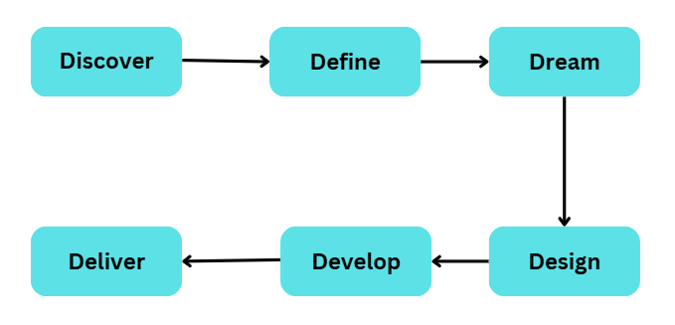

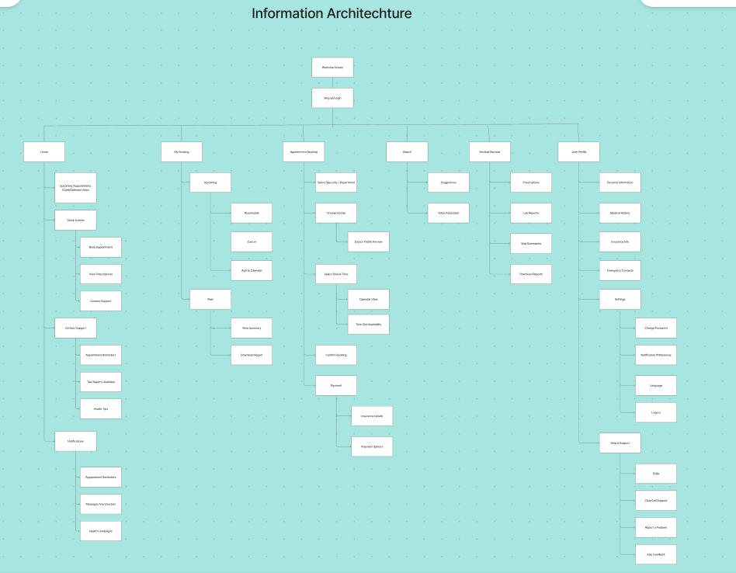

Figure 1. Information Architechture

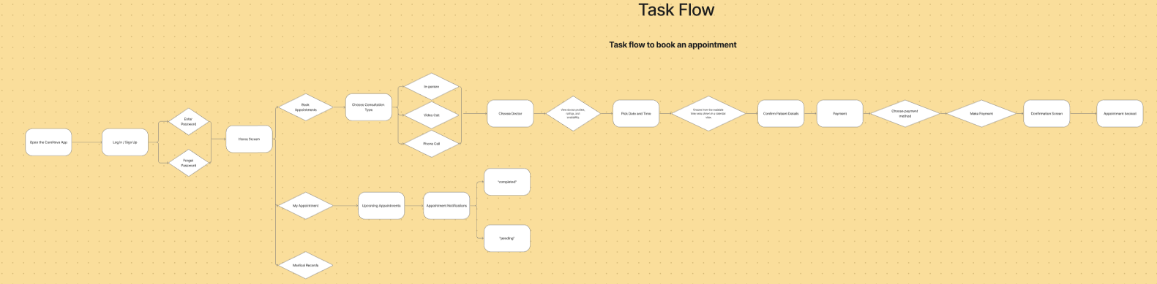

Figure 2. User Task Flow

# ****3.2 Data Description****

### **Data Source**

Data is collected from **online surveys with patients and clinic staff**, **existing app analysis** (Axon, Ada, Medanta eClinic, Health Tap, Practo), and **user reviews** available on Play Store/App Store.

### **Data Collection Process**

Surveys conducted through Google Forms.

Secondary research from app usage reports and articles.

Observations of clinic workflows.

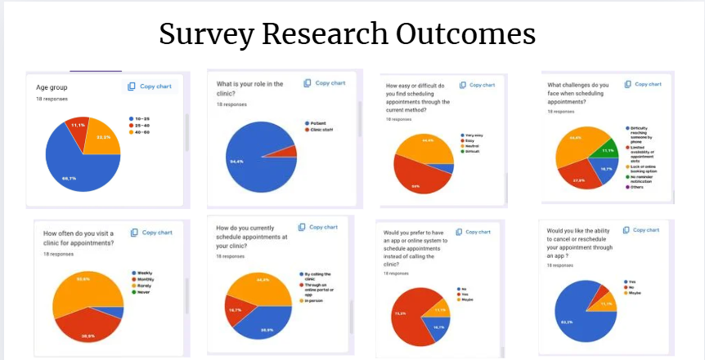

### **Data Type**

**Categorical**: User preferences, device usage.

**Textual**: Feedback, pain points.

**Numerical**: Appointment no-show rates, booking times.

### **Data Size**

20+ survey responses.

5 app analyses.

5+ clinic workflow observations.

### **Data Format**

Survey data: Google forms.

App reviews: Text documents.

Observations: PDF reports.

### **Data Preprocessing**

Cleaning missing responses.

Removing irrelevant data.

Normalizing rating scales (1-5).

### **Data Sampling**

Random sampling for survey respondents (patients of different age groups and clinics).

### **Data Quality Assurance**

Double-checking survey consistency.

Cross-verification with app store statistics.

### **Data Variables**

Independent: Age, Device used, Booking method.

Dependent: Booking success rate, Waiting time, Satisfaction level.

### **Data Distribution and Summary Statistics**

Most users preferred mobile over desktop.

60% users faced appointment delays.

Mean satisfaction score: 3.8/5.

# ****3.3 Exploratory Data Analysis (EDA)****

**Summary Statistics**: Mean waiting time = 20 min, Satisfaction average = 3.8/5.

**Data Distribution**: 75% of users prefer online booking over phone booking.

**Correlation Analysis**: Strong negative correlation between wait times and satisfaction.

**Categorical Variable Exploration**: Older adults prefer phone bookings; younger prefer apps.

**Missing Value Analysis**: 5% missing data, handled with mean imputation.

**Outlier Detection**: Removed extreme values (users claiming 5-hour waits).

# ****3.4 Procedure / Development Life Cycle****

### **Phase 1: Requirement Gathering**

Understand clinic challenges, patient expectations, and workflow needs.

### **Phase 2: Wireframing**

Create low-fidelity wireframes for key screens (Login, Home, Book Appointment, Appointment History).

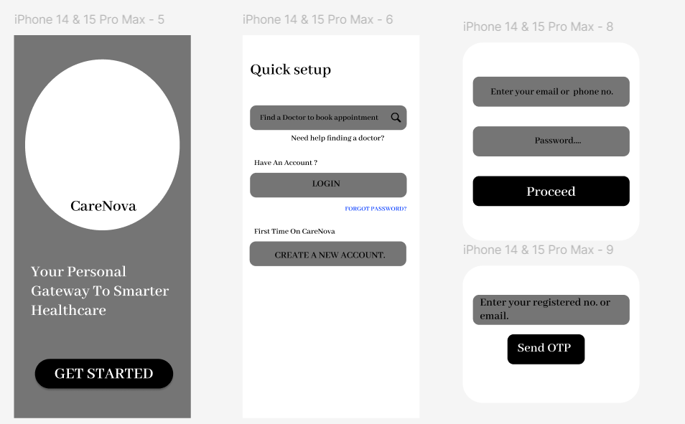

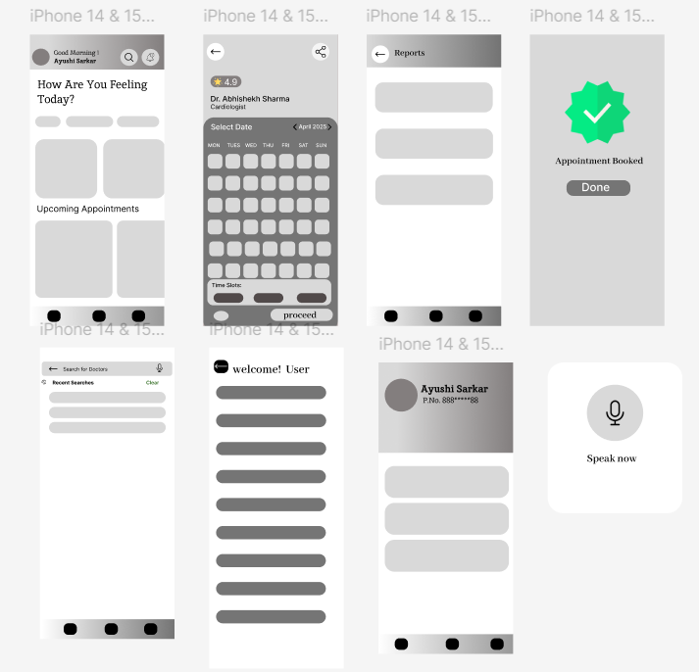

### **Phase 3: UX/UI Interface Design**

Design mobile-first, user-friendly interfaces.

Focus on minimal steps: Book, Reschedule, Cancel easily.

Accessibility features: Larger fonts, simple color schemes, intuitive navigation.

### **Phase 4: Frontend Development**

### Design responsive web app interface using Figma.

Prototype link :-

**[https://www.figma.com/proto/38bp0fVjzlVzs5z1M4Kfi3/Untitled?page-id=0%3A1&node-id=1-3&viewport=129%2C120%2C0.43&t=Xx6GMZfEnEoNczpf-1&scaling=scale-down&content-scaling=fixed&starting-point-node-id=1%3A3&show-proto-sidebar=1](https://www.figma.com/proto/38bp0fVjzlVzs5z1M4Kfi3/Untitled?page-id=0:1&node-id=1-3&viewport=129,120,0.43&t=Xx6GMZfEnEoNczpf-1&scaling=scale-down&content-scaling=fixed&starting-point-node-id=1:3&show-proto-sidebar=1" \t "_blank)**

Ensure fast load times, clean layouts, and dynamic updates.

Integrate interactive forms for easy appointment booking.

**Wireframes & Prototypes-**

The wireframe includes five key sections:

* Login Screen – Provides secure access with login and registration options.
* Home Screen – Central dashboard with quick access to appointments, profile, and reports.
* Profile Section – Allows users to view and edit personal details.
* Reports Section – Enables staff to generate and view appointment and patient reports.
* Appointment Scheduling – Lets patients book, reschedule, or cancel appointments with reminders. These features streamline clinic operations and enhance user experience.

1. **Details of tools, software, and equipment utilized.**

# ****Details of Tools, Software, and Equipment Utilized****

In the development of the **Automated Appointment Scheduling App for Clinics**, various modern tools and technologies are utilized to ensure smooth functioning, user-friendliness, and platform compatibility.

# ****Features Integrated****

**Appointment Booking Interface:** A simple, clean form for patients to schedule appointments.

**Patient Profile Management:** Basic dashboards for users to manage and edit personal information.

**Real-Time Calendar Integration:** Doctors’ availability displayed dynamically.

**Appointment Reminders:** SMS/email alert system for upcoming bookings (planned in future versions).

**Check-In/Check-Out Interface:** Easy check-in at clinic reception through minimal manual entry.

# ****Focus on UX/UI Design****

**Wireframing and Prototyping:** Designed using Figma/Adobe XD to structure screens logically.

**User Journey Mapping:** Ensured that appointment booking requires minimal steps for faster usability.

**Front-End Development:** Tkinter library used to build interactive, responsive screens.

**Simplicity and Accessibility:** The interface focuses on a clean layout, large buttons, and minimal text fields to serve users of all age groups.

**Error Handling:** Clear error messages and validations to prevent incomplete or wrong bookings.

**Chapter 5**

**Expected Results & Impact**

### **Expected Results:**

* Development of a **user-friendly and efficient** appointment scheduling app specifically tailored for clinics, ensuring an intuitive experience for both patients and healthcare providers.
* **Automation of booking processes**, including appointment creation, modification, and cancellation, reducing manual intervention.
* Significant **reduction in patient wait times** by enabling real-time scheduling based on doctor availability.
* **Minimized administrative burden** for clinic staff, allowing them to focus more on patient care rather than manual scheduling tasks.
* **Integration of automated reminders** (SMS/email notifications) to patients to lower no-show rates and improve attendance.
* **Secure and reliable data management**, ensuring patient details and booking information are stored safely.

### **Impact:**

* **Enhanced patient satisfaction** through quicker, hassle-free appointment experiences and better communication.
* **Optimized clinic operations** by improving scheduling accuracy, reducing double bookings, and minimizing idle time for doctors.
* **Increased accessibility** for patients, offering flexible appointment options without the need for phone calls or physical visits.
* **Better utilization of clinic resources**, leading to improved financial performance and service quality.
* **Support for data-driven decisions**, where clinics can analyze appointment trends to optimize staff planning and service offerings.
* **Encouragement of digital transformation** in healthcare management, pushing clinics towards more modern, patient-centric service models.
* **Inclusive design**, making the application accessible for patients of different age groups, including elderly users who may struggle with complex systems.

**Chapter 6**

**FUTURE SCOPE**

* **Integration with Electronic Health Records (EHR):**  
  The app can be expanded to automatically update and access patient medical records during appointment booking.
* **AI-Based Doctor Recommendations:**  
  Future versions can suggest the best available doctor based on patient history, symptoms, and availability.
* **Voice Assistant and Chatbot Integration:**  
  Voice-based booking and smart chatbots can be added for easier interaction, especially for elderly users.
* **Telemedicine Integration:**  
  Option to schedule **virtual consultations** directly through the app, improving accessibility for remote patients.
* **Advanced Analytics Dashboard:**  
  Clinics can use appointment trends, no-show rates, and patient feedback data for better decision-making.
* **Multi-language Support:**  
  Adding regional languages can make the app more user-friendly for diverse patient populations.
* **Blockchain for Data Security:**  
  In the future, blockchain technology can be implemented to enhance patient data privacy and security.

**CONCLUSION**

The development of the automated appointment scheduling system marks a significant step toward modernizing clinic operations and improving patient engagement. By offering a digital platform where patients can easily book, reschedule, or cancel appointments at their convenience, the system saves valuable time for both patients and clinic staff. This flexibility not only reduces the workload on administrative teams but also allows healthcare professionals to focus more on patient care and critical clinical tasks, ultimately enhancing overall productivity and operational efficiency.

Moreover, the system enhances the patient experience by providing 24/7 access to appointment services, eliminating the need for phone calls or in-person visits just to manage bookings. The integration of automated reminders through SMS and email helps reduce no-show rates, ensuring that appointment slots are better utilized and clinic schedules run smoothly. This proactive communication builds trust and satisfaction among patients, improving their loyalty and engagement with the clinic.

The project also emphasizes secure handling of patient information, ensuring that sensitive data is managed responsibly. As healthcare increasingly shifts towards digital solutions, such a system positions clinics at the forefront of technological adoption, leading to greater efficiency, better resource management, and an overall higher quality of service delivery.

In the future, with the integration of AI-driven recommendations, telemedicine features, and advanced analytics, this platform can evolve into a comprehensive healthcare management tool, further transforming the way clinics operate in a fast-paced digital era.

Thus, the automated appointment scheduling app is not just a technological upgrade but a strategic move towards a more patient-centric, efficient, and resilient healthcare system.

# REFERENCES

1. Woodcock, E., Sen, A., & Weiner, J. (2022). Automated patient self-scheduling: case study. *Journal of the American Medical Informatics Association*, *29*(9), 1637-1641.
2. North, F., Nelson, E. M., Buss, R. J., Majerus, R. J., Thompson, M. C., & Crum, B. A. (2021). The effect of automated mammogram orders paired with electronic invitations to self-schedule on mammogram scheduling outcomes: observational cohort comparison. *JMIR medical informatics*, *9*(12), e27072..
3. Gupta, S., Veshala, A., Kowsigan, M., Ramamoorthy, S., & Madhavan, P. (2024, November). A Near Optimal Patient Scheduling for effective Doctor Appointment System. In *2024 International Conference on Electronic Systems and Intelligent Computing (ICESIC)* (pp. 81-86). IEEE.
4. Akinode, J. L., & Oloruntoba, S. A. (2017). Design and implementation of a patient appointment and scheduling system. *Department of Computer Science, Federal Polytechnic Ilaro Nigeria*.
5. Nguyen, V. D. (2024). *Developing a Medical Appointment Scheduling System for Clinics (Medical Schedule)* (Doctoral dissertation, Vietnam-Korea University of Information and Communication Technology).
6. Parikh, A., Gupta, K., Wilson, A. C., Fields, K., Cosgrove, N. M., & Kostis, J. B. (2010). The effectiveness of outpatient appointment reminder systems in reducing no-show rates. *The American journal of medicine*, *123*(6), 542-548.